Methanol Fuel Cell Enabled Hybrid Power System

Process Global, Inc. (Sunnyvale, CA); Dr. Branden Kappes

Technical Category: 7.L Technologies for portable power applications

Estimated Total Project Cost: $3.6M

Project Duration: 3 years

**Summary**

Next generation portable electronics, remote monitoring and communications systems will increasingly require always-on technologies – such as powered sensors, continuous data acquisition, on-chip data analytics and communication– to improve functionality and extend into applications currently prohibited by relatively high energy demands.

Lithium ion batteries are sufficient to power existing portable systems, and operate at or near 100% Coulombic efficiency over both a wide state of charge and a wide range of currents. But low energy densities, below 150 Wh/kg (100 Wh/L), place prohibitive limits on the always-on state required for next generation functionality in portable devices, such as cellular phones and tablets. In contrast, direct methanol fuel cells (DMFCs) have theoretical energy densities in excess of 5000 Wh/kg (3000 Wh/L), but suffer from intrinsic electrochemical limitations to their use as stand-alone power supplies. Sluggish kinetics, and chemical-, mass transport-, and ohmic-polarization losses impede their ability to promptly respond to changes in power demand and result in a narrow optimal operating range, respectively.

A hybrid battery-fuel cell power system couples the energy density of a direct methanol fuel cell with the power response and wide operational efficiency of an all solid-state lithium ion battery (ASSLB). This project will, over three years, address the three challenges facing DMFC that impede their commercialization: high methanol crossover, high activation polarization, and poor anode catalyst longevity due to Ru dissolution. In order to reduce battery complexity, and improve the volumetric energy density, this project will improve battery technology through the development of an all solid-state lithium ion battery.

**Innovation and Impact**

A hybrid DMFC/ASSLB system will have a positive impact across several mission areas of ARPA-E. Methanol is currently produced at commercially viable levels by steam reforming natural gas, which the United States has in abundance, which would significantly reduce our dependence on foreign sources of liquid fuels. Furthermore, methanol may be produced from biomass through a syngas intermediate, reducing the production of greenhouse gases.

This technology could also significantly improve the efficient use of energy in the United States. Domestically, portable electronics (laptops, tablets, and cellular phones) operate on an estimated 87.5 gigawatt-hours per day. Limited by Carnot efficiency, power generation from fossil fuel-fed heat engines range in efficiency from 25% (petroleum-fed gas turbine) to 45% (natural gas-fed combined cycle), averaging 33%, excluding transmission losses. Therefore, powering portable electronics require an effective energy of 262.5 GWh per day. The use of methanol reduces electrical losses, increasing energy efficiency, by enabling distributed power generation. Steam reforming methane to syngas ranges in efficiency from 80-90%, from syngas to methanol, > 99%; and electrooxidation of methanol, thermodynamically limited to 97%. The sets an upper limit on the fuel-to-use efficiency between 77% and 87% and lowers the effective daily energy requirement of portable electronics from 262.5 GWh to 113.6 GWh.

Several technical challenges must be overcome, including challenges to the GO membrane, the catalyst layers, and to the lithium ion battery.

The theoretical energy density of DMFCs is reduced significantly by methanol crossover (permeability). Crossover current is made up of contributions from convective, diffusive, and electroosmotic drag. The latter dominates the crossover current densities in excess of 200 mA/cm2 (Bahrami2013). As electroosmotic drag is directly proportional to the methanol concentration at the interface, the fuel concentration is lowered from concentrated methanol (~24.7 mol/L) to < 2 M. While this does improve performance by reducing crossover, it also significantly lowers the energy density of the fuel. The proposed effort will use GO as a DMFC membrane to reduce methanol crossover, and will increase proton conductivity through the degree of oxidation and chemical modification of the GO membrane.

The density of GO surface defects impacts the proton conductivity, but neither the magnitude of this effect nor its affect on methanol crossover have been characterized. Similarly, through-platelet conduction is thought to occur through a proton transport mechanism that involves proton acceptor sites exchanging the proton through opposing faces of a GO sheet. Chemical modification of these sites is thought to improve this mechanism. This work will use dry chemical methods and ALD to chemically modify the GO surface without introducing additional structural damage to the GO sheet.

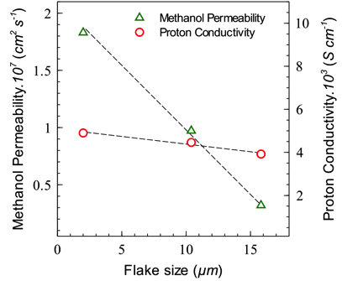

Figure 2 Methanol permeability (diffusivity) and proton conductivity through graphene oxide (GO) as a function of the mean nanoplatelet size. From Paneri2014.

Complete electrooxidation of methanol involves the formation of carbon monoxide, which poisons platinum catalysts. Extensive study has revealed that a Pt-Ru alloy is stable against CO poisoning, but dissolution of Ru in the acidic environment of the DMFC anode limits anode catalyst longevity. The proposed effort will increase catalytic activity by optimization of the catalyst synthesis to produce nanoparticles of prescribed morphologies, shapes and sizes. We will pursue the catalyst optimization by developing research synergies that combine computational tools (search algorithms, synthesis models, simulations of process or properties, etc.) with experimental methods/techniques of synthesis and characterization in order to predict desired materials and to achieve a fundamental understanding of their synthesis and/or control over the final product and its catalytic properties. The catalytic materials systems to be addressed in the proposal are metal nanoparticles (NPs), with or without core-shell morphologies. These well-defined catalytic systems are ideal for linking experiments and modeling, providing controlled systems for building selective and complex functionalities. The proposed effort will increase catalyst stability by lowering the solubility of Ru in acidic media. Our team has extensive experience in Pt-Ru deposition including wet chemical reduction (WCR), atomic layer deposition (ALD), and sputtering.

Solid-state electrolytes appreciably reduce the complexity of each lithium ion cell, reducing both weight and volume. Able to sustain a prescribed power- and short-term energy-requirement with a smaller cell, this volume and weight can be recaptured into increased fuel storage, multiplying the impact of any improvement in battery performance. An all solid-state battery using solid electrolytes instead of organic liquid electrolytes is expected to have higher energy density than a lithium ion battery using organic liquid electrolytes and having a bipolar stack structure. Furthermore, use of solid-state electrolytes will improve the safety and reliability of lithium secondary batteries. All-solid-state batteries can be divided into two types, thin-film-type and bulk-type. For large-scale applications, bulk-type ASSLBs with high loadings of active material and solid electrolyte powders, are well suited because of their high energy density. However, ASSLBs have crucial challenges for practical applications, such as poor rate performance and poor contact between the active material and the electrolyte. In order to overcome the problem of low ionic conductivity in solid electrolytes, such as LiPON, sulfide type electrolytes were developed. Sulfide-based solid electrolytes Li2S–P2S5 and Li2S–P2S5–GeS2 systems offer ion conductivity from 10-3 to 10-2 S•cm-1 at room temperature, similar to liquid electrolytes; and they have a high decomposition potential of 5 V. With these electrolytes, the maximum resistance is observed at the cathode/sulfide electrolyte interfaces. Thus, understanding the cathode/electrolyte interface has become an issue of the greatest importance for the improvement in ASSLBs.

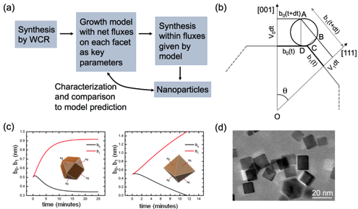

Figure 3 (a) Computationally guided synthesis of metallic nanoparticles by wet chemical reduction (WCR) –recent work at CSM by Richards and Ciobanu. (b) Key parameters of the computational model: net attachment rates for each facet. (c) Predictions of the model for different ratios of attachement rates to (001) and (111) facets. (d) Actual Pd cuboctahedra synthesized by Richards' group.

The resulting hybrid DMFC/ASSLB will be transformational. Such a system will allow the power and energy requirements of each application to be optimized independently. ASSLB promise 2-3 times greater energy density at a power density already sufficient for existing applications. Operating at a higher methanol concentration has the potential to introduce a 10-fold increase the energy density of existing direct methanol fuel cells. At even moderate improvements, the energy density of DMFC will surpass those of existing and emerging lithium ion batteries, therefore, any improvements in DMFC, battery, or hybrid system technologies will have a multiplying effect: any improvement to the energy density of the battery will allow for a smaller battery, increasing the fuel, and consequently, the energy capacity of the hybrid system.

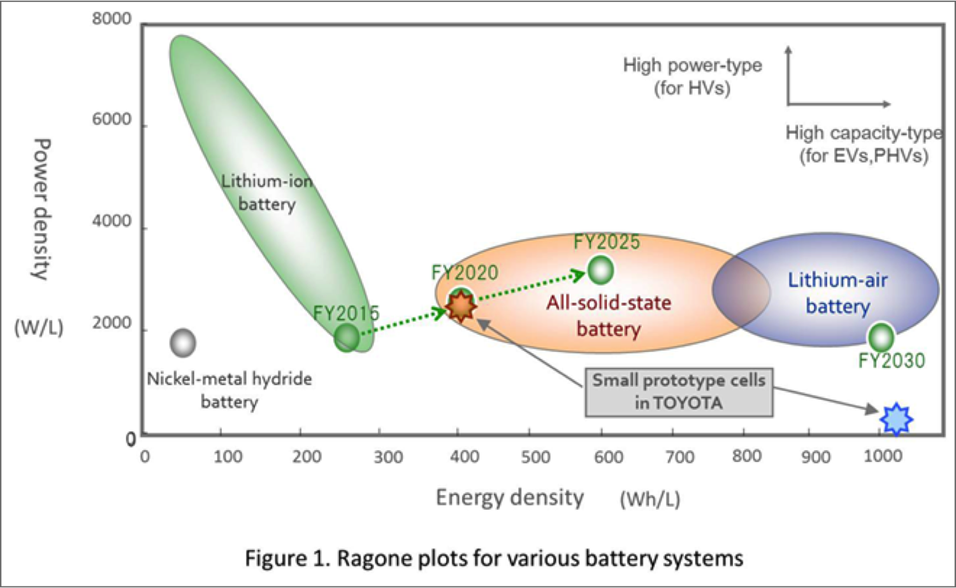

Figure 4 Ragone plot showing the timeline for the expected improvement in all solid-state batteries. Reference?

Compared to existing and emerging technologies, a hybrid DMFC/ASSLB power system will be disruptive. Currently, DOE targets 300 Wh/kg for lithium ion batteries, which will require significant improvements across all aspects of the lithium ion battery. Balance of plant structures in current and emerging Li-ion battery technologies set an upper bound of 195.74 Ah/kg. A 36% increase in *both* anode and cathode capacities, operating at 3.6 V, is required to meet five year energy targets of 300 Wh/kg. Although 4.8 V, high voltage spinels can theoretically achieve the 300 Wh/kg target, at these voltages electrolyte decomposition raises serious safety concerns. But even with these targets, still several years out, are achievable by an 18 M DMFC operating at 0.4 V, i.e. by improvements only in membrane technology.

Solid-state batteries hold the promise to lower the parasitic losses that result from the balance-of-plant structures in existing Li-ion chemistries by reducing each cell from current collectors, separators, lithium salt, electrolyte, anode, and cathode to current collectors, anode, cathode, and electrolyte. Reducing the mass of balance-of-plant structures by 50% would increase the capacity of existing graphite/LiCoO2 batteries by 15%. Absent electrolyte breakdown concerns, high voltage spinels would lead to a 20% increase, without requiring discovery of new electrode compounds. More/less/change?

Compared to other fuel cell options, DMFCs combine the use of high energy density fuels typical of high temperature solid oxide and phosphoric acid fuel cells with the low operating temperature of hydrogen fuel cells. A commercial attempt at solid oxide fuel cells for portable applications was able, through extensive developments in most aspects of cell design, to lower radiant losses by nearly two orders of magnitude. Absent cogeneration however, and despite these advancements, radiant losses still accounted for ~50% of the energy generated by this system, ultimately precluding this solid oxide fuel cell design from practical consideration. Furthermore, thermal cycling of these high temperature fuel cells and the highly corrosive electrolyte of phosphoric acid fuel cells severely limit longevity in the highly cyclical nature of portable energy generation. Initially, recent commercial release of hybrid hydrogen fuel cell-battery systems raises questions about the disruptive and transformative potential of a hybrid DMFC/ASSLB. However, while liquid hydrogen has a significantly higher energy density by mass, cryogenic hydrogen is impractical for portable applications. Methanol has ten times (two times) the gravimetric (volumetric) energy density of hydrogen stored as a metal hydride, and, because it is liquid at room temperature, greatly simplifies both handling and distribution.

Several technical performance and cost targets are necessary to affect a disruptive technology. For DMFC, these include an increase in the methanol concentration from 2 to 10 M; an increase in methanol permeability from 50 to 0.25 mA/cm2 (Zhao2009, Corti2014); and increase the proton conductivity for GO from 0.0045 to 0.05 S•-2 (Paneri2014, Sone1996); and a twofold reduction in price, from $550/kWh to $250/kWh (Kamarudin2009).

ASSLB targets include in increase in lithium conductivity from XXX to YYY; improved electrode – specifically cathode – contact with the electrolyte; an increased energy density from 250 to 400 Wh/L; and a cost reduction from $1450/kWh to $1000/kWh (Kararudin2009).

**Proposed Work**

Year 1 will focus on the development of individual components with significant improvements toward the target performance metrics. This will include:

* Synthesis and characterization of candidate graphene oxide and chemically modified GO membranes: proton conductivity, methanol permeability, and temperature sensitivity. Modifications to GO will include… Molecular dynamics simulations of defects on the graphene oxide surface, and their proton transport mechanisms will be used to evaluate the efficacy of chemically modified GO membranes.
* Synthesis and analysis of the stability, activity, and performance of the anode catalyst layer under conditions near and around those expected during fuel cell operation. Improvements to the catalyst will involve modeling and growth/deposition of Pt-Ru alloy nanoparticles.
* Synthesis and characterization of a solid state battery electrolyte: lithium conductivity, cycle stability, …
* System level modeling efforts will be put in place to pre-optimize operating conditions based on the properties of the catalyst layer, membrane and battery properties.

Year 2 will focus on the achieving the target performance metrics for all individual components. Fuel cell components will be integrated into a test cell for controlled performance testing at the Energy Systems Integration Facility at NREL. Solid-state battery components will be integrated into a coin cell configuration for electrochemical testing.

Year 3 will optimize the performance of the integrated fuel cell and battery systems under simulated real-world operational variations. Merging the fuel cell and solid-state battery into a hybrid power system will be done at PGI.

Chemical modification of GO has been seen to improve the proton conductivity to values within the range of Nafion® (Sott2012a), but other reports indicate a corresponding increase in methanol permeability (Jiang2014). Sulfonation has been shown to significantly increase proton conductivity at low methanol concentrations (Jiang2012), but at higher concentrations, the sulfonic acid groups on the GO surface induce a methanol/water phase separation that reduces proton conductivity (Paneri2014). The precise nature of proton transport through GO is not known, but the insensitivity of proton transport to flake size (Fig. X) suggests through-platelet transport plays a dominant role; contrarily, the large drop in methanol permeability over that same range indicates methanol permeation occurs predominantly at platelet edges. It is thought that this phase separation phenomenon does not occur with the non-sulfonated GO surface defects because of their lower acidity. Surface modification of GO using vapor phase methods including ALD and molecular layer deposition (MLD) will enable the development of GO membranes resistant to phase separation and cracking (?).

PGM activity has been seen to increase on novel substrates, such as CNT and ceria (Feng2013a), and is known to have a significant NP shape dependence. What work has been done in addressing catalytic activity?

What work has been done in ASSLB?

By combining battery technology with direct methanol fuel cells, advancement in this hybrid system does not hinge on improvement in any single technology, but rather benefits from every individual improvement: in battery capacity, catalyst activity, or membrane performance.

Key technical risks include…

Technical risks will be mitigated by…

Several techno-economic challenges exist that stand in the way of commercialization. Both anode and cathode require platinum and platinum-group metal catalysts. Typical loading levels, 2.5 mg/cm2 on each catalyst layer, account for a price of $1366/kW, based on platinum at $1162/oz. At this cost, the price per kilowatt is in line with existing lithium ion batteries (Kararudin2009), but does not provide a sufficient cost-reduction incentive to justify changing technologies.

**Team Organization and Capabilities**

**Project Prime**: Process Global, Inc. brings to the table…

*Principle Investigator*: Dr. Branden Kappes is an expert in… and will provide…

**Project Partner**: NREL will bring…

*Key Member*: Dr. Chunmei Ban is an expert in… and will provide…

*Key Member*: Dr. Steven Christensen is an expert in… and will provide…

*Key Member*: Dr. Katherine Hurst is an expert in… and will provide…

**Project Partner**: Colorado School of Mines will bring…

*Key Member*: Prof. Cristian Ciobanu is an expert in… and will provide…

Within the last three years, all members of the current team have collaborated on projects relevant to the proposed effort. Drs. Ban and Kappes collaborated on an ARPA-E funded project on organic flow batteries that completed December 2014, and have numerous publications on lithium ion batteries. Drs. Ciobanu and Kappes have collaborated on… Drs. …